

**User Manual**

Group 1

陈巍炜、窦艺初、韩永欣、侯宇捷

金子昂、李婷婷、孙利峰

Content

Introduction 3

Overview 3

History 3

Supported File Formats 4

Comparison 4

How to use it 6

Reference Collection 6

Reference Management 9

Reference Citation 11

Reference Sharing 15

Features 19

Improvements 25

# Introduction

EndNote is a citation management and reference management software that aids academic researchers, students, and professionals in organizing, storing, and referencing their bibliographic resources. The following is an overview of EndNote, its development history, and supported file formats.

## Overview

EndNote provides a robust platform to assist users in:

1.Collecting, organizing, and citing references

2.Easily creating academic papers, research reports, and other scholarly documents

3.Storing and managing bibliographic information

4.Automatically generating reference lists and citing references

## History

EndNote is a popular reference management software developed by Clarivate Analytics. It has a rich history dating back several decades. Here is an introduction to the history of EndNote:

1. Early Development (1980s): EndNote was originally created by Dr. Edward Madson, a computer programmer, and Dr. Roger Clarke, a renowned immunologist, in the late 1980s. It was first developed for Macintosh computers and was initially called "Niles Software." The idea for EndNote stemmed from the founders' need for a tool to manage their own reference collections efficiently.
2. Commercialization (1993): In 1993, Niles Software was officially incorporated as "Niles &amp; Associates, Inc." and the software was renamed "EndNote." This marked the beginning of EndNote as a commercial product.
3. Cross-Platform Support (1998): In 1998, EndNote expanded to support both Windows and Macintosh platforms, broadening its user base considerably. This move made it one of the few reference management software options available to users of both major operating systems.
4. Acquisition by ISI and Thomson Reuters (2008): In 2008, the Intellectual Property &amp; Science business of Thomson Reuters acquired the EndNote product line. This acquisition further strengthened EndNote's presence and brought it under the Thomson Reuters umbrella, a well-known provider of academic and scientific information.
5. Integration with Web of Science (2011): Under Thomson Reuters, EndNote was integrated with the Web of Science platform, enhancing its citation and reference management capabilities. This integration made it easier for researchers to access and import references from the extensive Web of Science database.
6. Acquisition by Clarivate Analytics (2016): In 2016, the Intellectual Property &amp; Science business of Thomson Reuters was divested and became Clarivate Analytics, which retained ownership of EndNote. EndNote continued to evolve and improve under Clarivate's management.
7. Resolve compatibility issues (2021): EndNote remains one of the most widely used reference management software solutions worldwide. It continues to receive updates and enhancements to meet the needs of researchers, academics, and professionals in various fields
8. Current Status: As of my last knowledge update in May 2023. Clarivate brings tagging to Endnote, which gives us a new document management strategy outside of groups.

EndNote's long history, cross-platform compatibility, and integration with research databases have made it a trusted tool for researchers to manage their references, citations, and bibliographies. Please note that there may have been further developments or changes to EndNote's history since my last update in 2021.

## Supported File Formats

EndNote supports a wide range of file formats, including but not limited to:

1. Bibliographic Databases: EndNote is compatible with various databases such as PubMed, Web of Science, Scopus, and more.
2. Document Types: It supports different types of documents, including journal articles, books, patents, presentations, theses, reports, and more.
3. File Formats: EndNote can import and manage various file formats, including PDFs, Word documents, image files, and more.
4. Citation Styles: EndNote supports various citation styles such as APA, MLA, Chicago, Harvard, allowing users to select different styles as per their requirements.

## Comparison

Here is a summary of the differences between EndNote and other mainstream reference management software presented in a tabular form:

|  |  |  |  |  |
| --- | --- | --- | --- | --- |
| Feature | EndNote | Zotero | Mendeley | RefWorks |
| Platform | Windows and macOS | Windows,macOS, Linux | Windows, macOS, Linux | Web-based |
| Citation Management | Robust citation management and referencing capabilities | Citation management, supports tags and folders | Citation management, tags and folders | Citation management and organization tools |
| Import and Export | Supports multiple file formats | Supports various file formats | Supports various file formats | Imports and exports various file formats |
| Collaboration and Team Features | Limited collaboration features | Limited collaboration features | Collaboration and team features | Robust collaboration and team management features |
| Figures and Attachment Management | Supports PDF attachments | Limited attachment management features | Supports figures and attachment management | Supports figures and attachment management |
| Community Support | Limited community support | Strong community support | Community support | Community support provided |

Please note that each reference management software has its unique features and use cases, and the choice of software depends on the user's needs and preferences. EndNote excels in citation management and professionalism but may require a purchase. Zotero and Mendeley offer free versions and have strong community support. RefWorks is a web-based reference management tool suitable for users who need access to their reference library across multiple devices.

# How to use it

The available functions of EndNote can be divided into the following four categories: reference collection, reference management, reference citation, and reference sharing. Here are the steps to use each of them

## Reference Collection

1. **Online Search**

EndNote’s search interface provides a simple way to do basic searches of online databases. To search and retrieve references from an online database, you should initiate the online search from the Tools menu, select ONLINE SEARCH to display the collection of connection files installed on your computer or click Plus button to select the desired database, from which you can retrieve references.

* 1. Click Plus button to add and select a database .

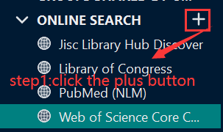

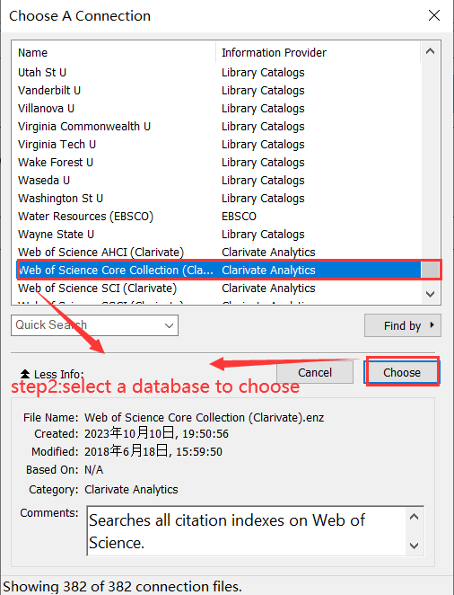

* 1. Select a database on your computer.



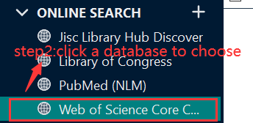

1. **Retrieve References**

Once you select a database, you will see several search fields appearing on the window. Enter your search request in the search fields on the Advanced Search panel, and then click Search. EndNote searches the database and displays the number of references that were found to match your search criteria.

1. Add/Delete search field.

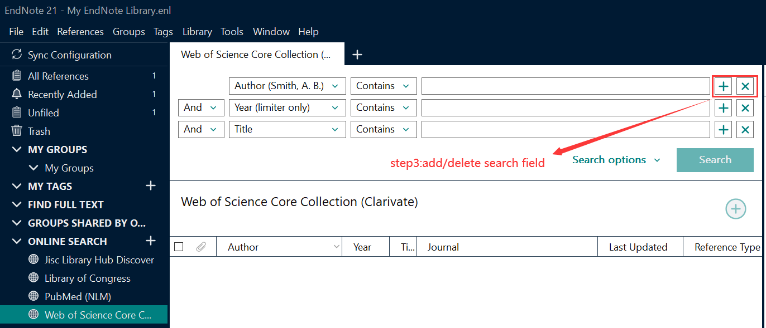

1. Set search field title.

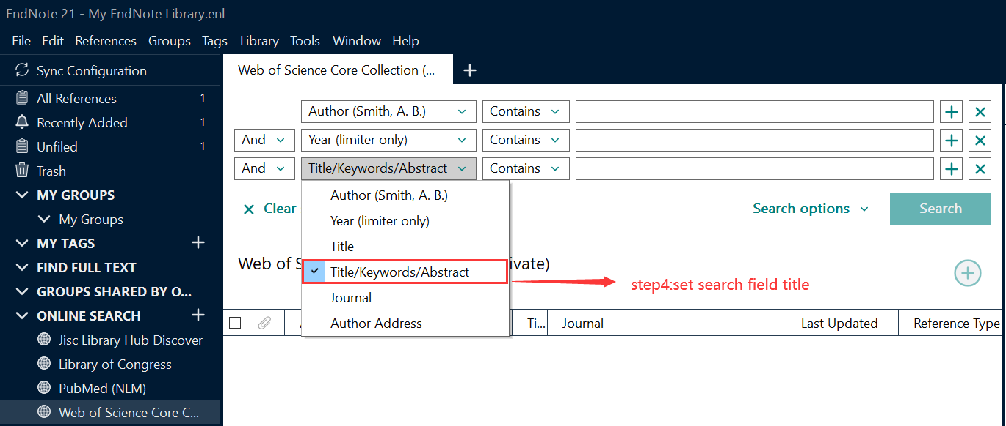

1. Enter keywords.

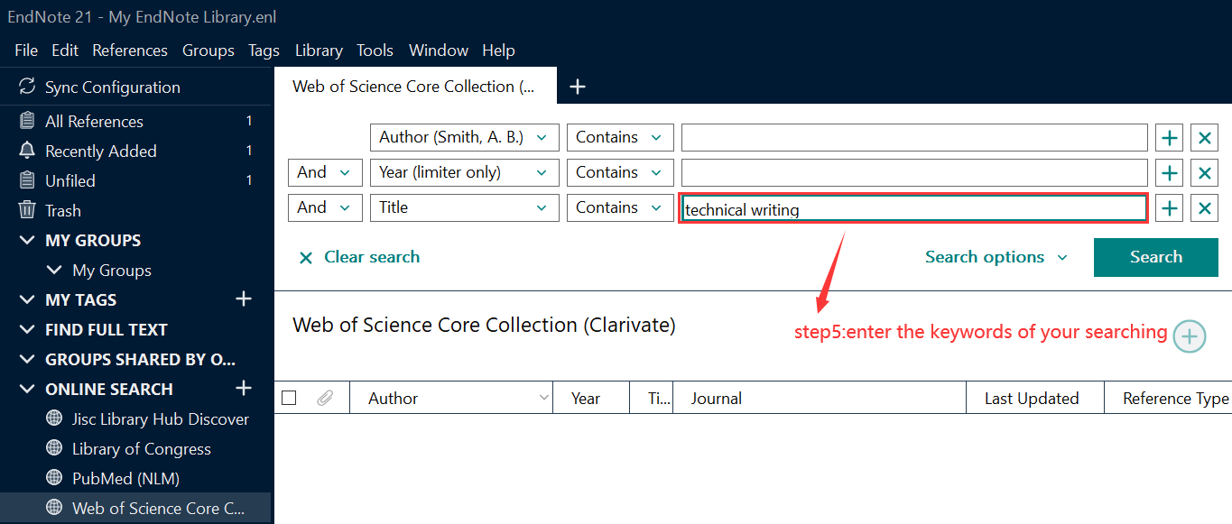

1. Click Search.

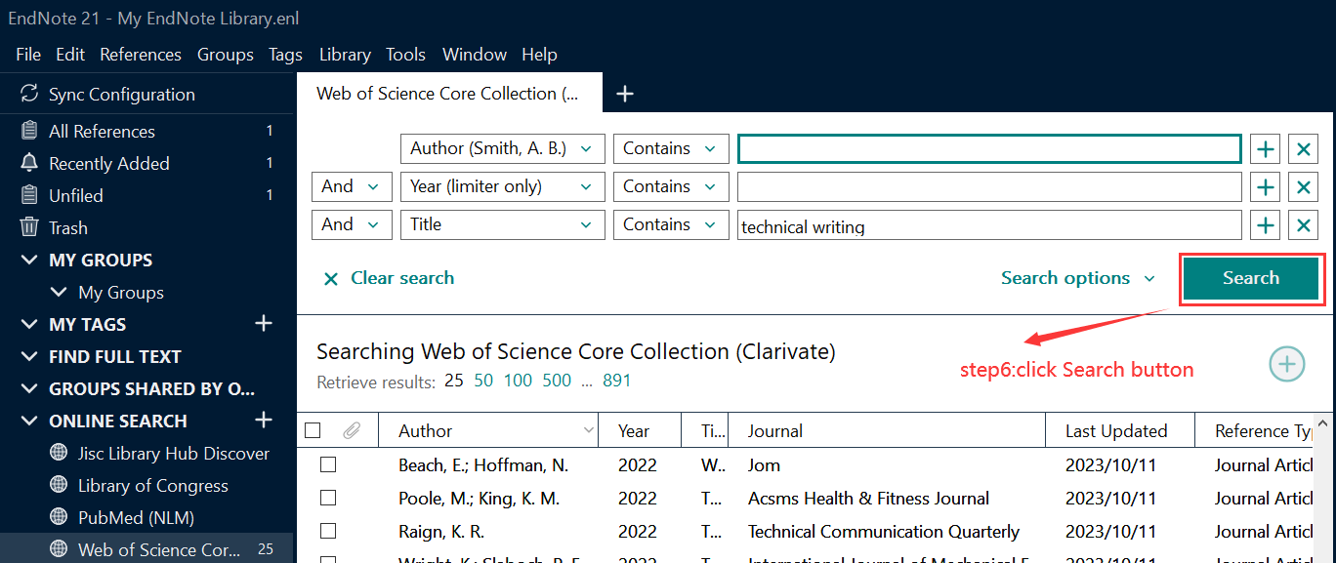

1. **Copy Retrieved References**

After you click Search button, the retrieved references are stored in the Online Search group set for the library, but they are not yet in your EndNote library. Now you have choices on how to add the references to your library.

* 1. Go to the References menu and select Copy References To in order to select a new or existing library and copy the selected references to that selected library.

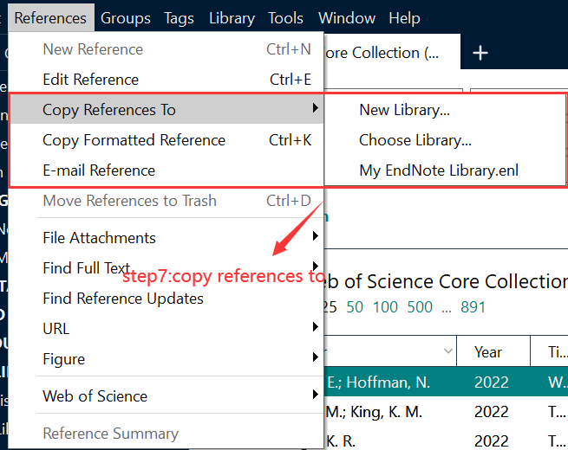

* 1. Right-click on the selected references and select Copy References To from the list in order to select a new or existing library and copy the selected references to that selected library.

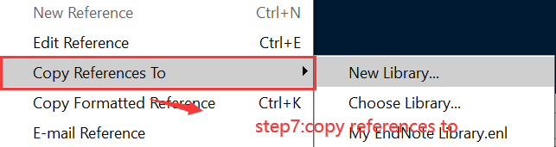

* 1. Drag and drop the references into the group you want to add them to in the library.
  2. Mark the references using the checkmark boxes to the left of them, and then click the Add the selected records to your local library button to add them to your library.

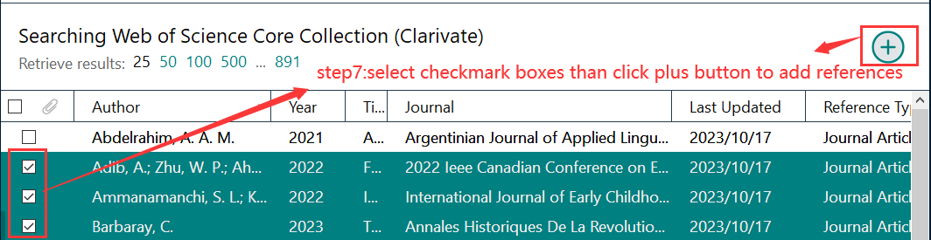

## Reference Management

The mechanism for organizing your EndNote library is called **‘Groups’**. Like a filing system, you can create a group and add references to that group manually. There are three different groups in EndNote.

* **Group:** A custom set of references
* **Smart Group:** A group based on the search result of an EndNote library. The references in a Smart Group are automatically added or removed according to the search parameters and the search result.
* **Group set:** A set of Groups.

1. **Creating a Group**
   1. In Endnote, select **Create Group** from the **Groups** menu. A new folder will appear in the **MY GROUPS** section in the left side of the user interface. Please feel free to rename the group name and press the **Enter** of **Return** key when finished.

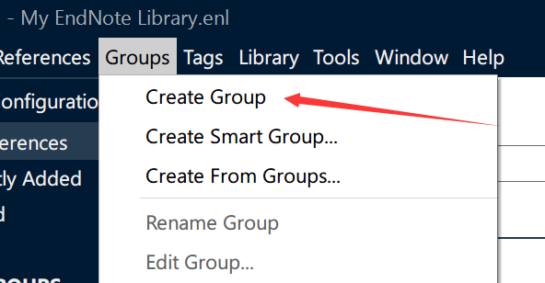

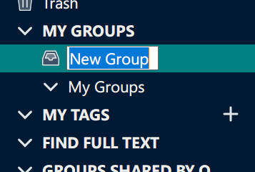

* 1. Select the references you want to add to your new group. By holding down the **CTRL** key and clicking on each reference you want with the mouse cursor, you can select multiple reference at one time. Or you can hold down the **SHIFT** key and click the first and the last reference to select a sequence of references. The selected references will be highlighted in blue.



* 1. right click one of the selected references, select ‘Add References To’ from the left click menu and then select the group that you want to add the selected references to.

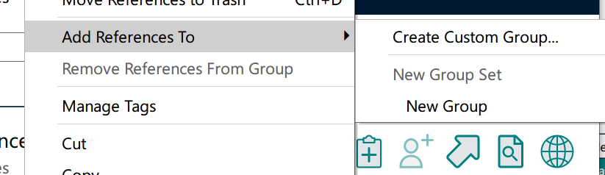

1. **Creating a Smart Group**
   1. In Endnote, select **Create Smart Group** from the **Groups** menu and name the Smart Group in the window appeared.

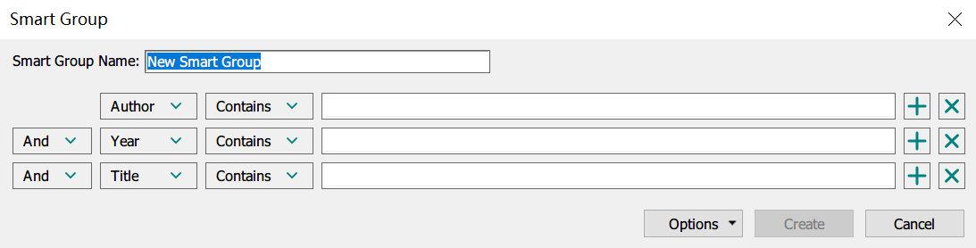

* 1. Still in the window appeared. Customize you search strategy and click **Create** to create the smart group as you need.
  2. All the references that fit your search strategy are added the smart group. It should be known that all the references you add to the library later will be added to the smart group automatically if they fit the rules.

1. **Creating a Group Set:**
   1. In Endnote, select **Create Group Set** from the **Groups** menu. name the new group set.
   2. **Drag and drop** a group into the group set. repeat the procedure until all the groups you want is successful added to the group set.



1. **Creating From Groups**
   1. In Endnote, select **Create From Groups** from the **Groups** menu. name the new group and customize the strategy. Click **Create**.

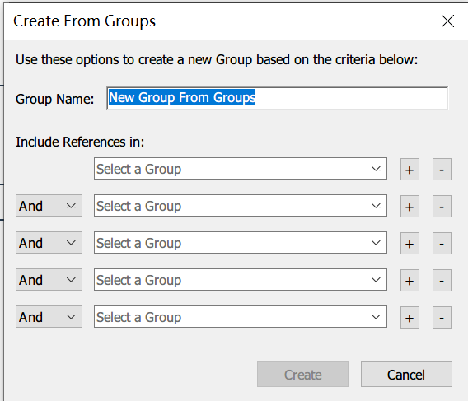

* 1. a new group is created according to your strategy and the existing groups. It should be known that all the references you add to the library later will be added to the group automatically if they fit the rules.

## Reference Citation

1. **Adding Reference to Your Library:**
2. Manual Entry:

🞄Click on the ‘Reference’ menu.

🞄Select ‘New Reference’.

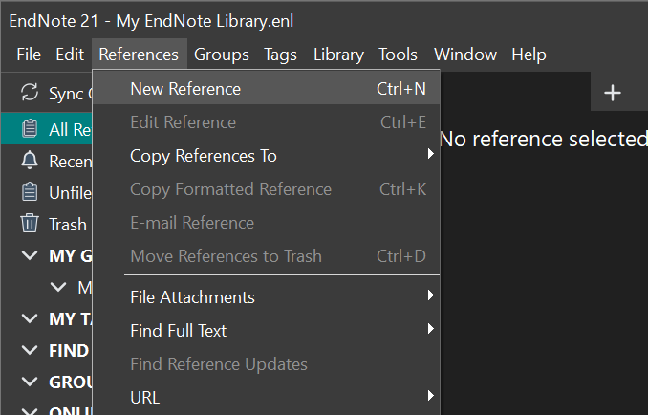

🞄Choose the type of reference you are adding (e.g., Journal Article, Book).

🞄Fill out the relevant details in the fields provided.

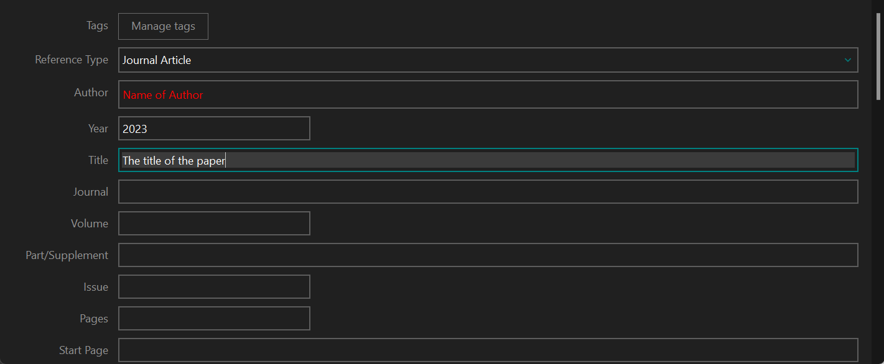

1. Importing from Databases or Journals:

🞄Search your desired database or journal website.

🞄Find the option to export citations (often labeled as “Export to Endnote” or “Citation Manager”), using ACM as an example.

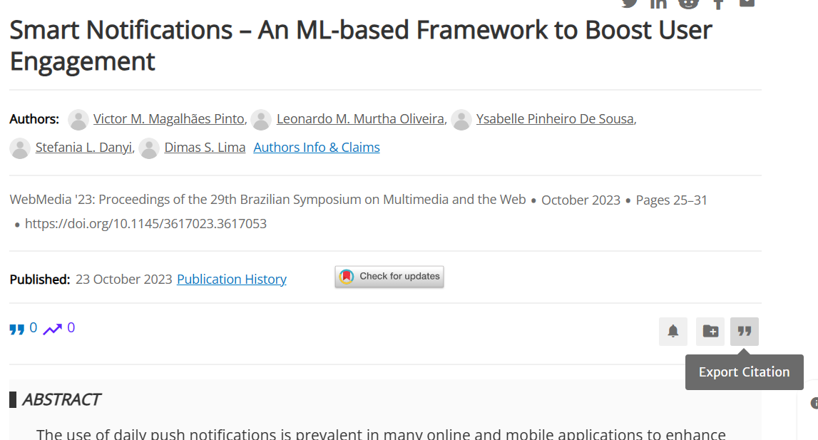

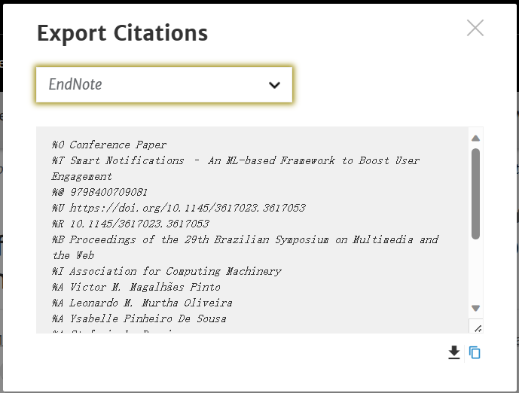

🞄Save the file and then import it into Endnote 21 using ‘File’ > ’Import’.

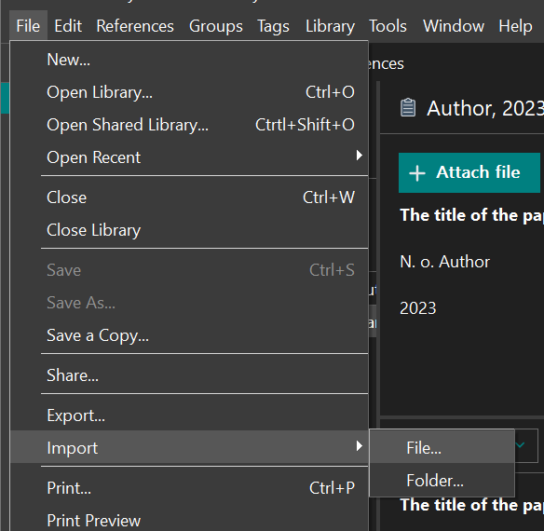

1. **Organizing References:**
2. Create groups to organize reference by topic, project, etc. by right-clicking on “My Groups” and selecting ‘Create Group’.

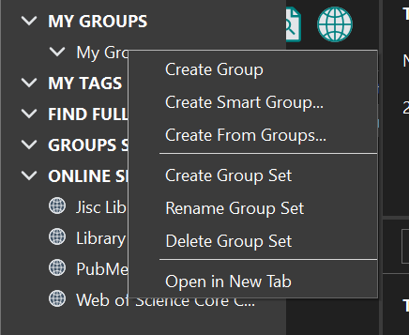

1. Drag and drop references into these groups or use the ‘Add References To’ option.

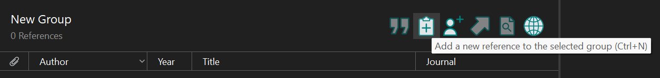

1. **Citing References in Your Document:**

**For Word Users:**

1. Launch your document and position your cursor at the intended citation location.
2. Navigate to the Endnote section in Word.
3. Select ‘Insert Citation’.

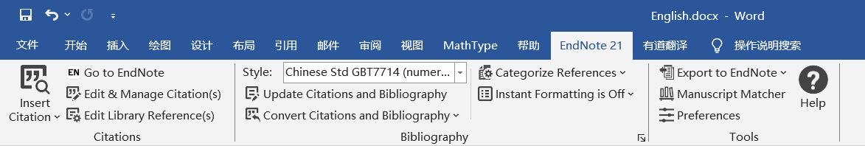

1. Locate and affirm the desired reference.
2. The citation is generated automatically with the selected format.

**For LaTeX Users:**

1. In Endnote 21, pick the reference you want.
2. Save as .bib file:

🞄 Click ‘File’ > ‘Export’

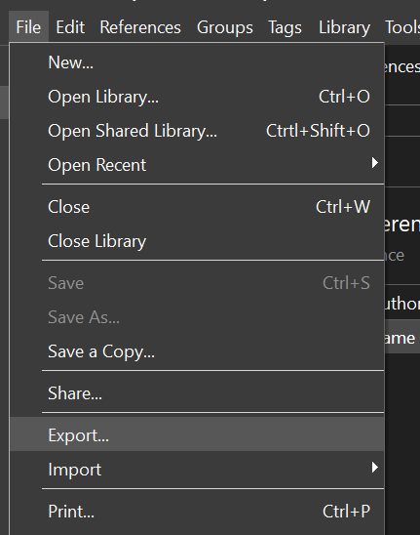

🞄For “Save as type”, choose Bibtex.

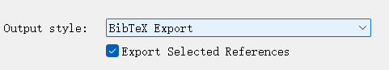

1. Drag the saved '.bib' file into your LaTeX project folder.
2. Use standard LaTeX citation commands(e.g., \cite{key}). The “key” is a name from the '.bib' file for that reference.
3. **Modifying Citation Formats:**
4. In Endnote 21, go to ‘Edit’ > ’Style’.

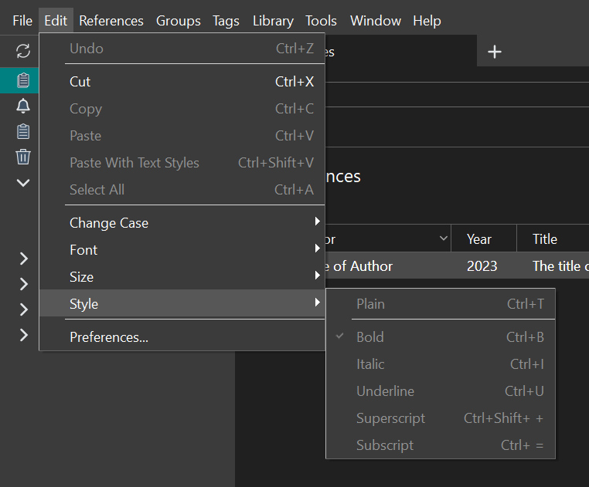

1. Choose the desired style or select Open Style Manager to find more styles.
2. Edit the style if needed and save your changes.
3. **Making a List of References:**

After you’ve added all your citations:

1. Click the Endnote tab at the top.
2. Click ‘Bibliography’ or ‘Insert Bibliography’.

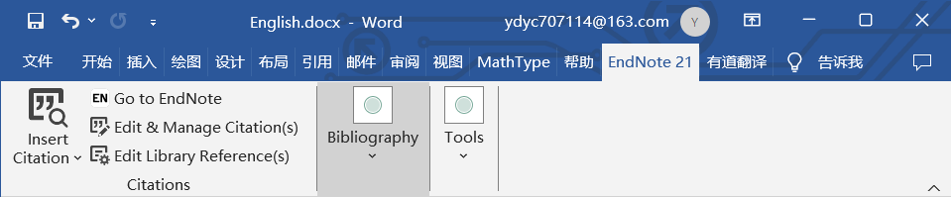

1. The list of all cited references will be generated automatically at the end of your document.

## Reference Sharing

**Method 1**

1. **Copy Files and Send to the Recipient**
   1. Find the location of your EndNote library and copy two files (one with the **.enl** extension, which is the database file, and the other with a **.data** folder extension) to a folder.
   2. **Send** the folder to the recipient using a USB drive, email, chat software, or any other method.



1. **Unzip the File and Import**
   1. The recipient can **unzip** the two files and copy them to their preferred location on their computer.
   2. Open EndNote, click on the menu bar, select **File** and **Open Library**. Then choose the file with the **.enl** extension to import references shared by others. In this way, you can import the reference shared by others.

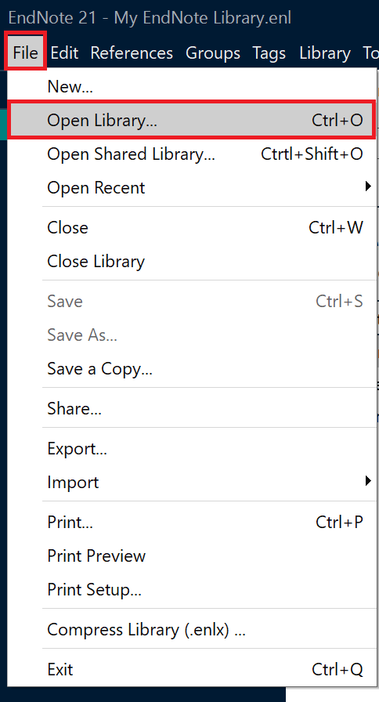

**Method 2**

1. **Generate a File and Send to the Recipient**
   1. Open the menu page, select **File** and **Compressed Library**.

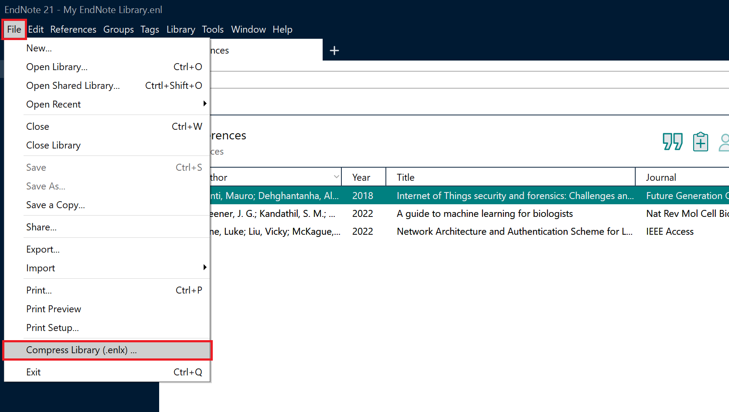

* 1. On the pop-up page, you can set the corresponding conditions. Here you can choose **With** or **Without File Attachments**, whether you want to include **All References** or **Selected Reference(s)** or **All References in Group/Group Set**. Then click the **Next** button.

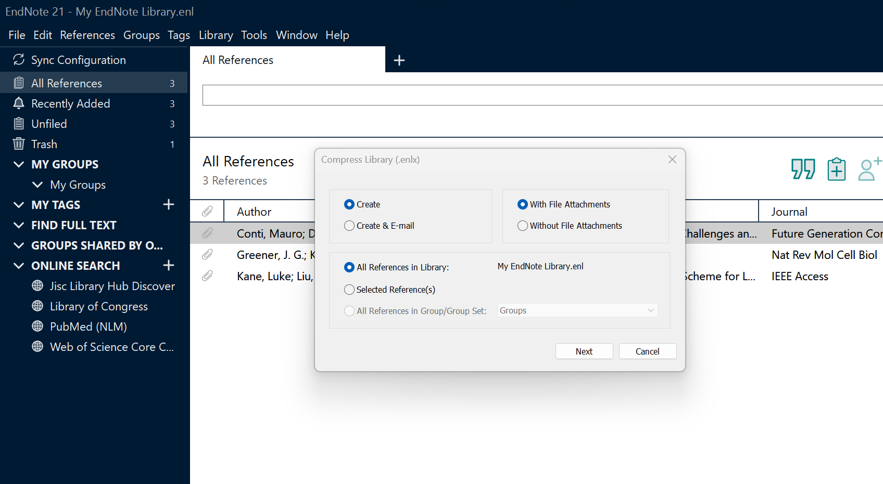

* 1. EndNote will generate a **compressed file** with the **.enlx** extension, and you can then share this compressed file with others.

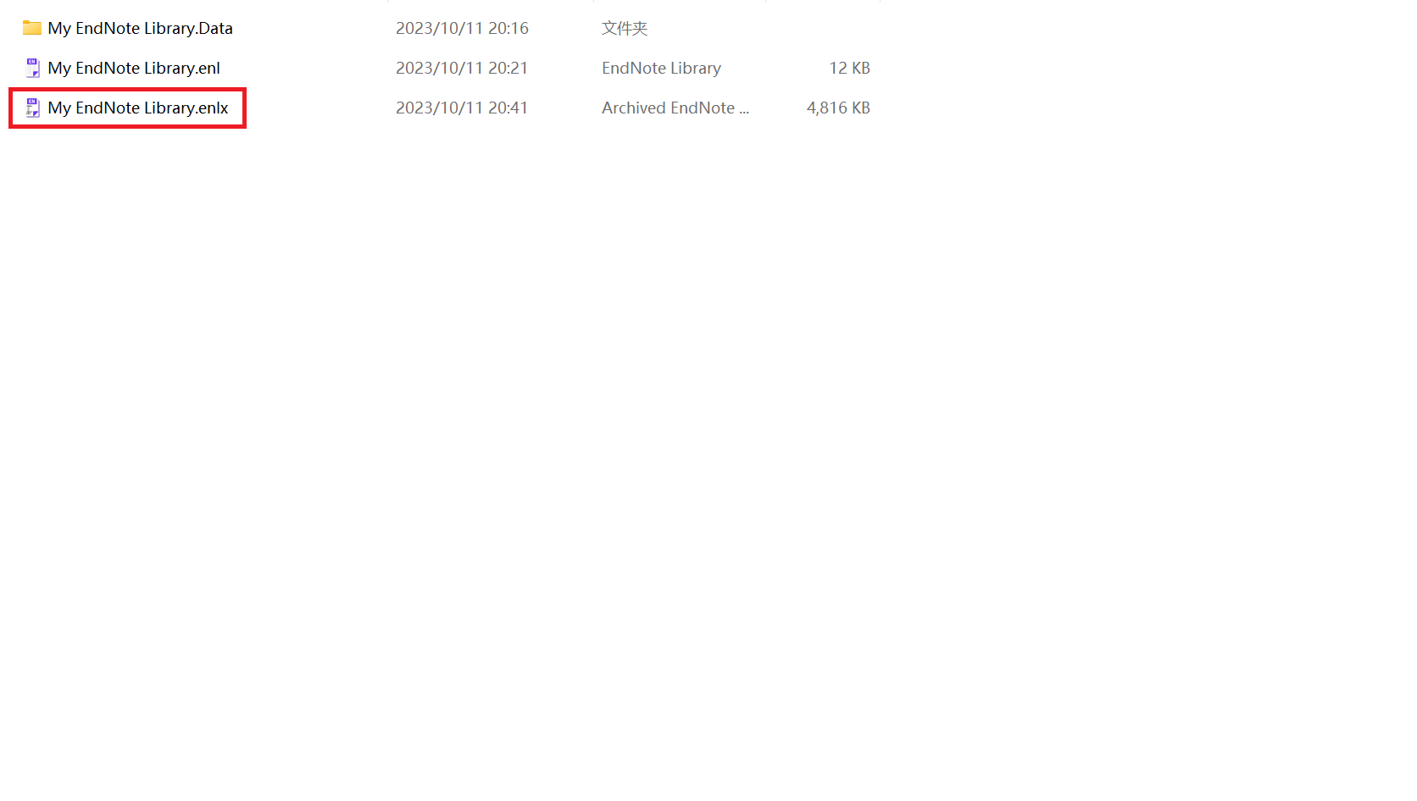

1. **Import**
   1. The recipient can **double-click** the file with the **.enlx** extension. This will extract two files: one with the .enl extension (the EndNote library file) and another with a .data folder extension.

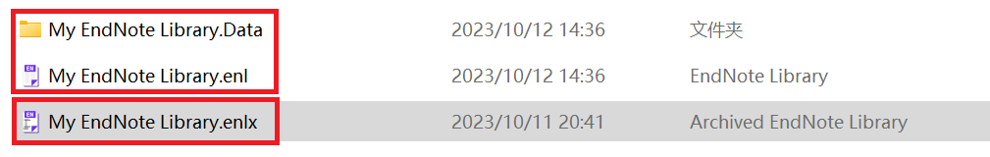

* 1. Open EndNote, click on the menu bar, select **File** and **Open Library**. Then choose the file with the **.enl** extension to import references shared by others. Or instead of unzipping the file first, the recipient can directly choose the file with the **.enlx** extension to import references.



# Features

1. **User-Defined Filed**

Fields are provided for users to mark, recognize, and filter references. Each reference has its own fields, which can be imported from academic resources or written by users themselves, as the following figure shows.

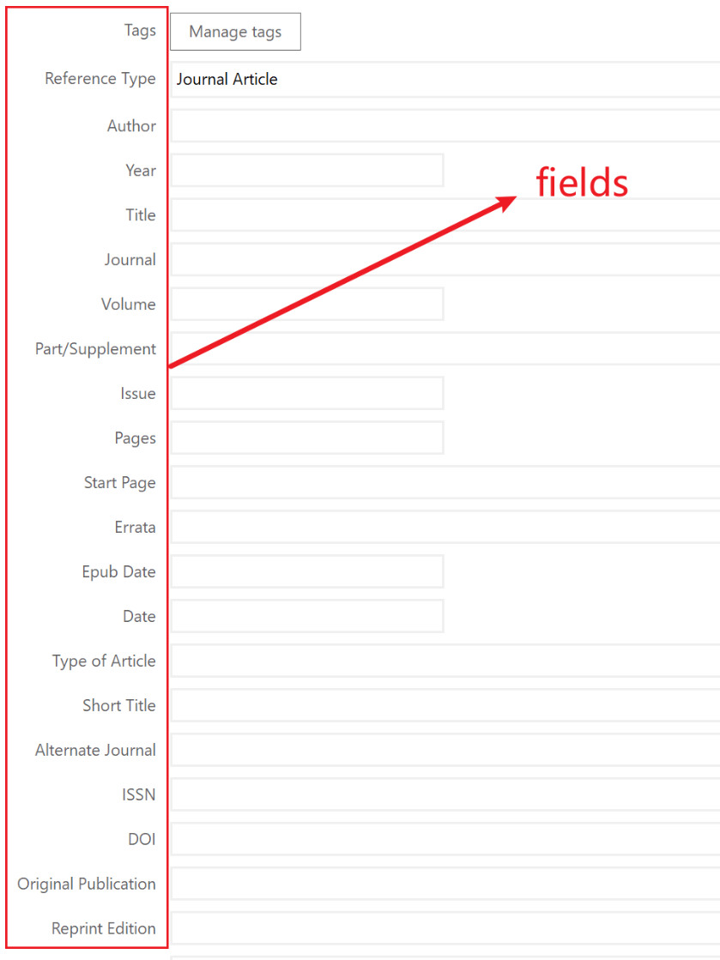

If the default fields provided by Endnote are not sufficient for your needs, you can add a customized field type according to your requirements. Steps are as follows:

1. Manual Entry:

🞄Click on the ‘Edit’ menu.

🞄Select ‘Preferences’.

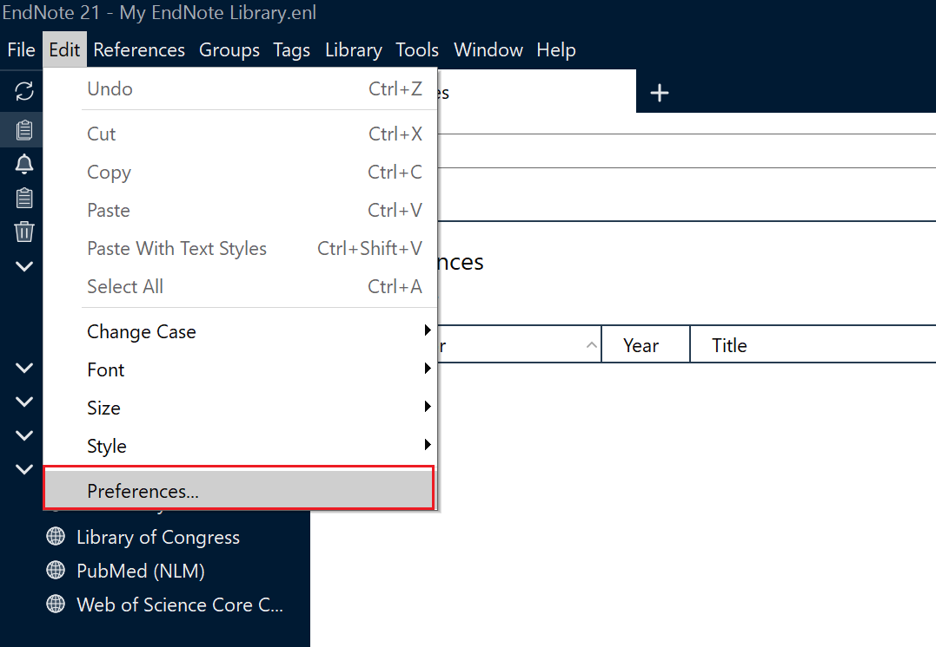

1. Preferences Setting

* Click the ‘References Types’.
* Choose ‘Default Reference Type’.
* Click the ‘Modify Reference Types’.

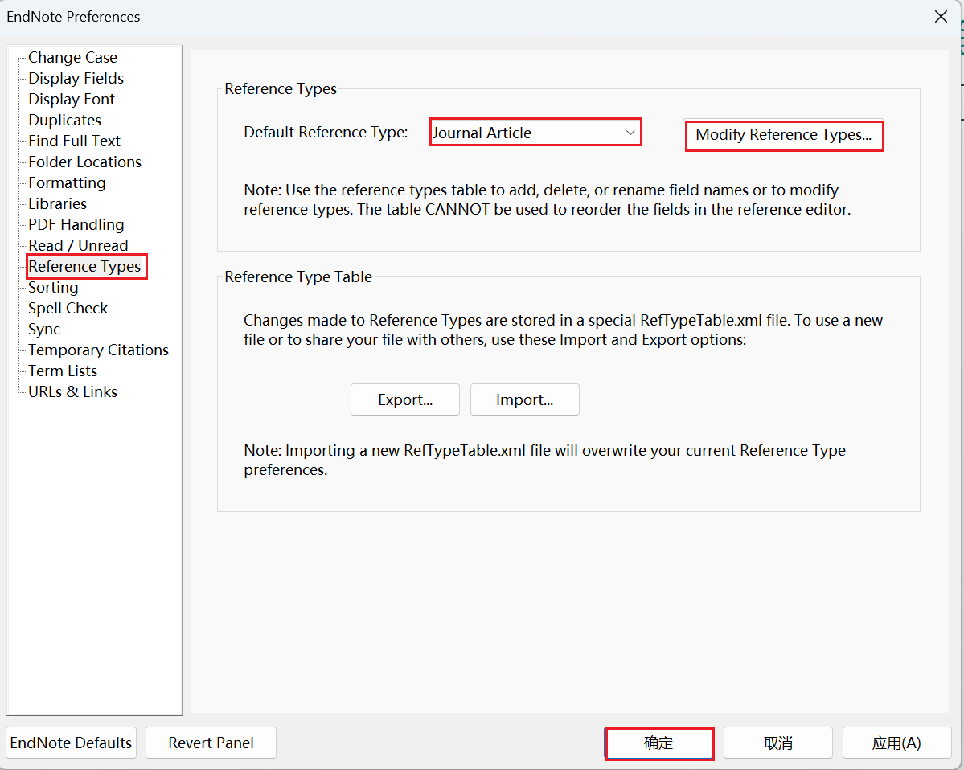

1. Modify References Type

* Find the ‘Custom’ bar.
* Add the field name you need, e.g. ‘Fit Technical Writing’,.
* Click ‘OK’.

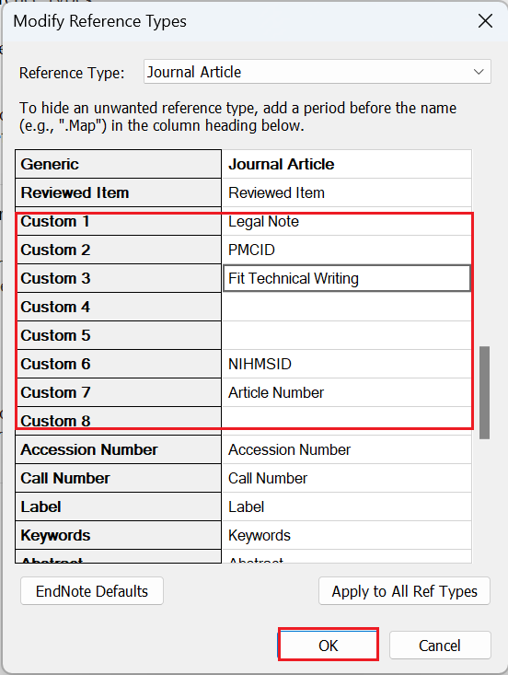

1. Result In Reference Interface

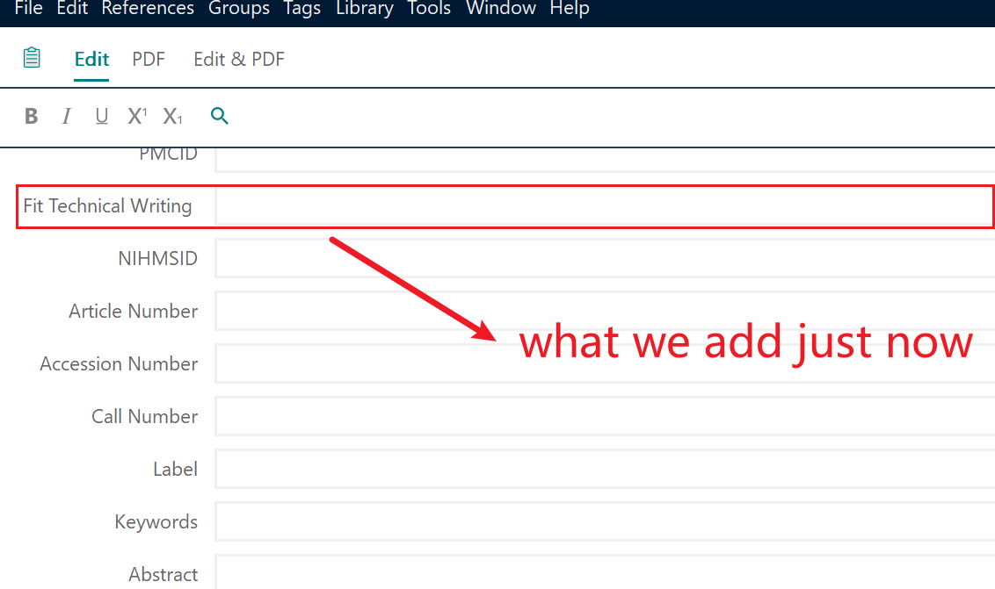

1. **Display Specific Field**

In the area of literatures, default fields are listed as the figure shows.

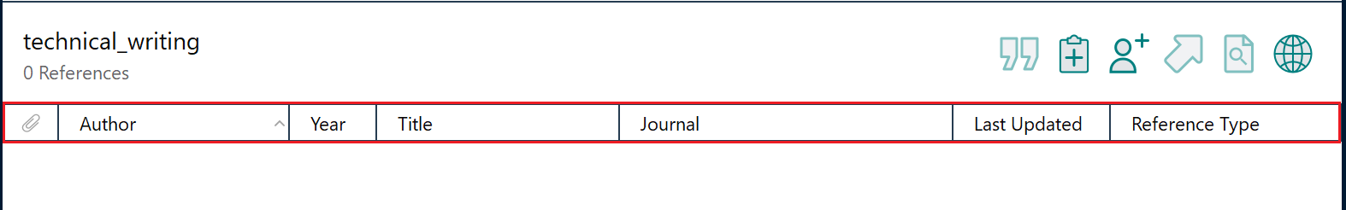

To change the type of fields displayed here, following steps are needed:

1. Open the setting interface through clicking the icon at the right part of the following figure.

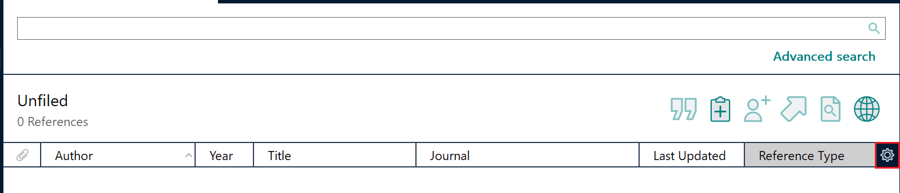

1. Set Display Fields

* Change the according field and heading of the column position you want to display.
* Click ‘OK’ button.

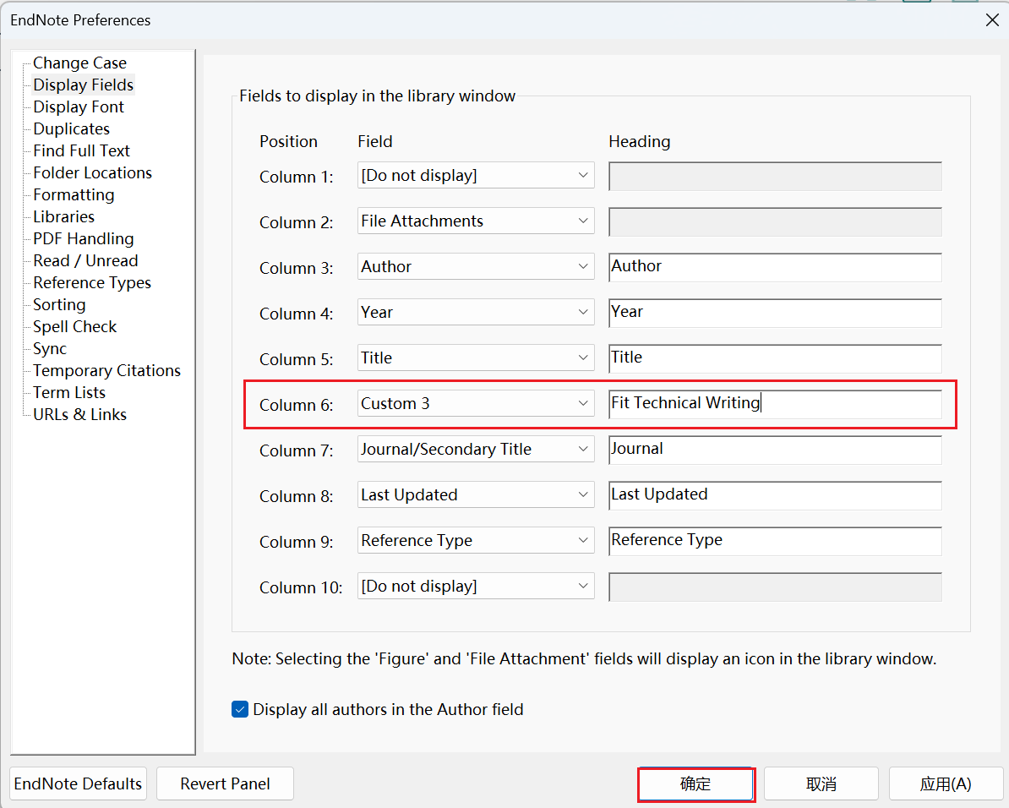

1. Result in Literature Area

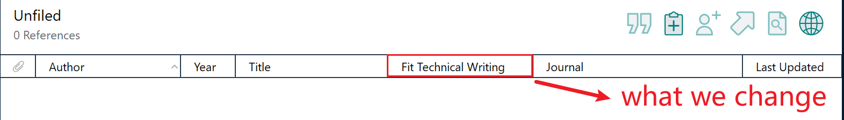

1. **Tags**

Besides groups, Endnote provides you with another tool named tag to help manage your references.

1. Create a tag

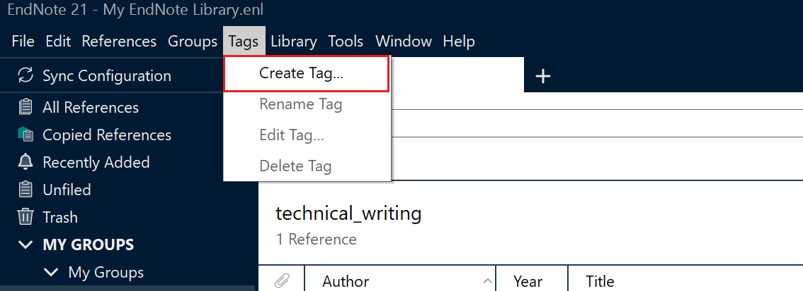

🞄Click on the ‘Tags’ menu.

🞄Select ‘Create Tag’.

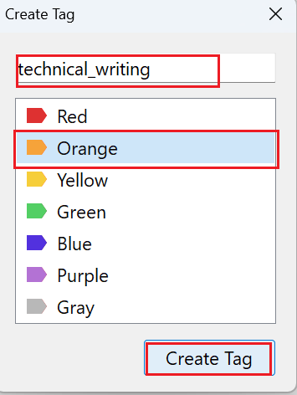

🞄Decide on your tag name

🞄Choose a color for the tag.

🞄Click on the ‘Create Tag’ button.

1. Allocate a reference to a tag

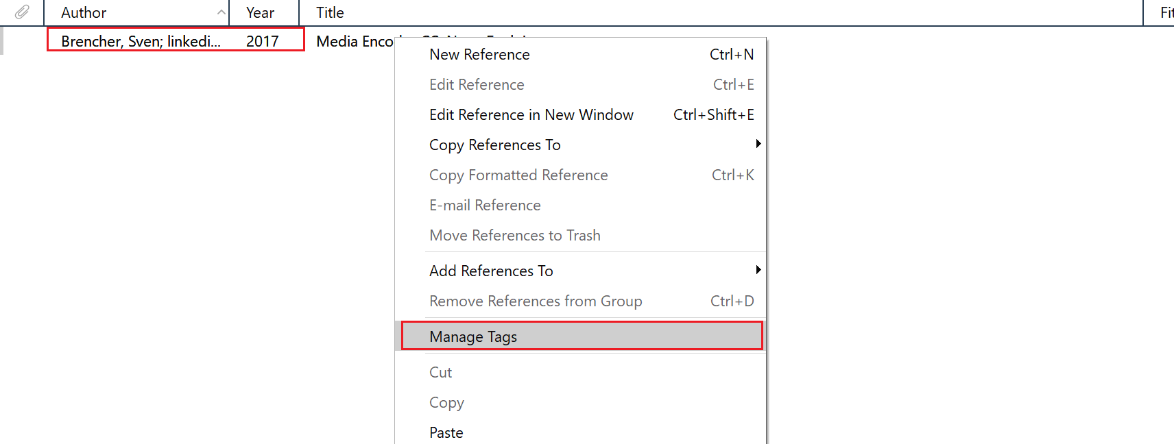

🞄Right click at a chosen reference

🞄click on ‘Manage Tags’

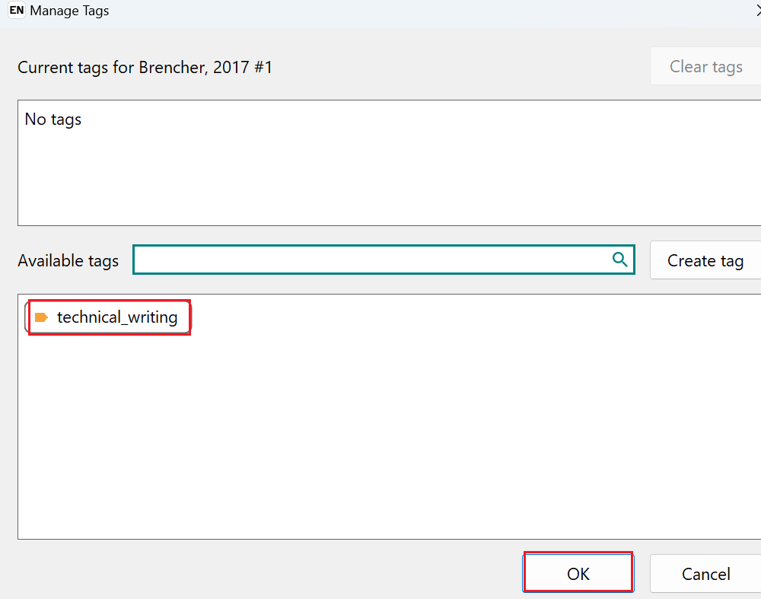

🞄Choose the tag created just now

🞄Click on ‘OK’ button



Here we can see the chosen reference is allocated to the selected tag.

# Improvements

EndNote is a very popular document management tool, but there are some areas where it could be improved. The following are some of the areas that may need improvement:

* 1. **User Interface**: EndNote's user interface may be somewhat outdated and may not be intuitive enough for new users. Improving the user interface to make it more modern and easy to use would enhance the user experience.
  2. **Integration**: Integration with other research tools (e.g., Word, PDF readers, etc.) may need to be improved to simplify the process of citation management and document insertion.
  3. **Sharing and Collaboration Features**: Improvement in sharing and collaboration features will help study teams to collaborate, share repositories and co-edit documents more easily.
  4. **Online Synchronization**: More robust online synchronization features will allow users to access their repositories on different devices and ensure data security and consistency.
  5. **PDF Management**: Improving the management of PDF files and annotation tools can increase the efficiency of users in the process of document management.
  6. **Automatic tag and subject line assignment**: The improvement in automatic assignment of tags and subject lines to documents can help users to organize and retrieve documents more easily.
  7. **Performance and Stability**: Some users have reported performance issues with EndNote, such as slowdowns or crashes. Better performance and stability will increase user satisfaction.
  8. **Price**: EndNote is relatively expensive, especially for students and individual researchers. It would be a good step to offer more pricing options or subscription plans to meet the needs of different users.

For Chinese users or users who only use Chinese as their daily language, they would like to see some specific improvements that would help them use EndNote better, including:

1. **Chinese Database Support**: EndNote should provide better support for Chinese databases so that users can import Chinese documents, including journal articles, dissertations, etc. more easily.
2. **Chinese Search**: EndNote should provide better support for Chinese searching to ensure that users can effectively search and filter Chinese documents.
3. **Chinese Character Support**: Improve the handling of Chinese characters (including Chinese characters and Pinyin) to avoid garbled characters or format errors.
4. **Chinese Reference Types**: Support for Chinese-specific reference types, such as Chinese dissertations, patents, conference papers, etc.
5. **Chinese Style**: More Chinese citation styles can be provided to meet the requirements of Chinese academic publishing.
6. **Chinese User Interface**: Provide a full Chinese interface and options to help users who only use Chinese to get started.
7. **User Training and Support**: More Chinese-language documentation, training, and support resources will help Chinese users get the most out of EndNote.